Robust Photosynthesis in Dynamic Environments

Picture: <http://imgur.com/qKmwS> (old one, originally pulled from a Reddit forum, I could have sworn it was CC, but I can’t find that attribution anymore)

This one is CC: <http://maxpixel.freegreatpicture.com/Seasons-Of-The-Year-Summer-Winter-Autumn-Spring-1127760>

Or something like it…

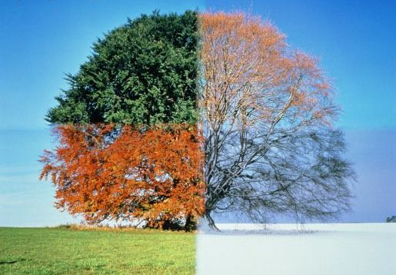

Caption/Summary: *Plants require consistency in photosynthesis, but natural environments are unpredictable in many ways. How do plants adapt the core functions of photosynthesis to “hedge their bets” against ever changing conditions?*

**Main text:**

Plants rely on absorption of light energy to meet their biochemical needs for cell maintenance, growth, and defense. Decades of research have given us a detailed understanding of the core cell machinery required for light capture. These components have been studied the most thoroughly under highly controlled laboratory conditions.

In contrast, natural environments are highly unpredictable: light conditions can change in fractions of a second, while rapid changes in other environmental factors, such as temperature or moisture, can affect how well the photosynthetic machinery can operate. This is particularly a concern for the organism, because an imbalance between the light absorbed and the utilization of this energy can lead to the formation of destructive by-products (Reactive Oxygen Species: ROS) and photodamage.

A major challenge in plant biology is to better understand how photosynthetic reactions are managed and tuned in natural environmental conditions. After all, plants evolved in an ever-changing environment, and the photosynthetic machinery is accordingly compensated in order to anticipate unexpected changes. Furthermore, the photosynthetic compensatory mechanisms must adjust the system for short term changes, such as fluctuating light from a passing cloud, and over sustained events, such as heat waves.

Despite the importance of these support functions to the growth and stability of plants in the real world, the nature of these components and how they interact with the core photosynthetic machinery is relatively unexplored.

Understanding these processes is critical, not only for fundamental research purposes, but also to engineer crops with higher photosynthetic efficiencies and increased yields to tackle the problems of climate change, feeding billions more people, and producing biofuels with cleaner environmental footprints.

C:\Users\ducatdan.CNS\Dropbox\MSU\Committee\Website development committee\Text for research projects\Project A Ramping severity.tifPart of the difficulty in studying these components is the lack of good tools to approach the problem systematically. An ideal platform would possess the following features: 1) capacity to grow plants in dynamic, reproducible conditions; 2) real-time monitoring of photosynthetic parameters over long time periods; 3) capacity to process a large number of plant strains and mutants; 4)ability to rapidly analyze and interpret the large datasets that result from such experiments.

Caption/Summary: *Laboratory conditions do not capture the dynamic changes in environmental conditions that exist in nature, yet, scientific practice requires some minimization of the variables in order to rigorously test a specific phenomenon. A challenge to the study of photosynthesis is how can we bring “field-like” conditions to the lab in a controlled manner? Technology developed within the PRL seeks to mimic natural environmental fluctuations in a controlled manner that is reproducible and can be studied with high throughput.*

The PRL is tackling these challenges through a combination of strategies, such as:

1. developing new scientific instruments (ex: Dynamic Environmental Phenotyping Imagers, aka DEPI );
2. collaborating with researchers across Michigan State University with expertise in established methods of studying photosynthesis;
3. taking advantage of large on-campus collections of plants with distinct ecotypes and mutants;
4. having developed automated data processing streams and bioinformatic pipelines.

Ultimately, this enables our team to “bring the field to the lab.”

For example, PRL growth chambers allow a researcher to program in fluctuating, yet reproducible conditions. It is possible to gather environmental data from a natural site – say light and temperature readings from an Autumn day in a Michigan park – and then replay these conditions faithfully within the chamber.

On-board detectors monitor the growth and health of the plant lines and can determine how efficiently their photosynthesis proceeds without destroying the plants, by using spectroscopic and fluorescence sensors. Furthermore, crowdsourced analysis of plant performance allows for data gathering from all across the globe, including a wide range of real-world conditions.

In this way, the PRL is uncovering the functions of heretofore unknown genes that are essential to protect photosynthesis against environmental fluctuations and stresses.

GIF here? I am envisioning one of the heatmaps that Dave does in closeup to one or two plants. I could make a series of small cartoons that indicate that the light conditions are being changed over time. Perhaps if we can get an image of three plants in a row, one that looks “not like the others” we could show an image of them grown in “normal light”, then switch to a picture of the same three plants in “dynamic” light with the middle plant suddenly standing out in a different pseudocolor.